How sustainable investing can help you make more informed decisions

When it comes to investing, a lot of focus is placed on how much money a company makes. It can be just as valuable to know how a company makes its money. Here we explore how a sustainable investment approach could help identify risks and potentially deliver long-term value.

What is sustainable investing?
Sustainable investing is a long-term investment approach that incorporates environmental, social, and governance (ESG) factors into the investment process. It’s an approach to investing that can assist to reveal broader risks and help to identify potential opportunities. ESG factors, at times, have also been known to affect the risk and return of investments.

Some investors want to know they are investing in companies rated as having strong sustainable practices. Others see ESG as a set of factors often overlooked in traditional analysis that should be incorporated for a more complete assessment of an investment.

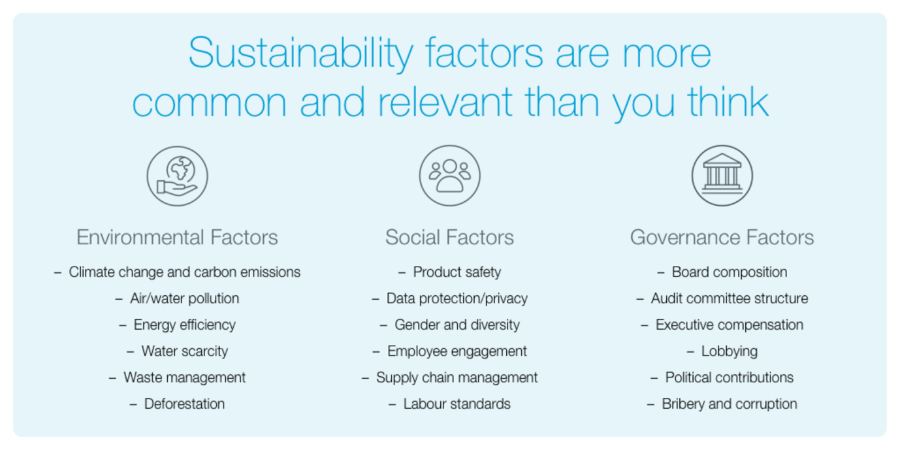

Management of ESG factors by a company could affect its performance
Investors typically look for companies positioned for long-term success. How a business operates – ethically, environmentally and socially – can provide an indication as to whether it is prepared to manage ESG risks.

For example, the 2010 oil spill in the Gulf of Mexico caused BP’s share price to fall sharply and reinforced the need to analyse ESG performance indicators. When South African mining company Lonmin experienced a breakdown in its relationships with its workforce in 2012, it caused significant and direct impact on the company’s financial performance. And governance issues relating to Enron’s balance sheet contributed to the company’s bankruptcy in 2001 resulting in severe losses for shareholders.

A sustainable investment approach may help to identify risks associated with ESG factors that can potentially impact long-term investments.

It’s not just about being ethical or socially responsible
Some investors choose not to invest in certain companies based on ethical grounds - for example taking a stance against investing in tobacco. This approach is called ethical or socially responsible investing. Sustainable investing, on the other hand, is also motivated by financial goals, aiming to identify potential value and/or manage risks by comparing companies based on how they manage key ESG factors.

